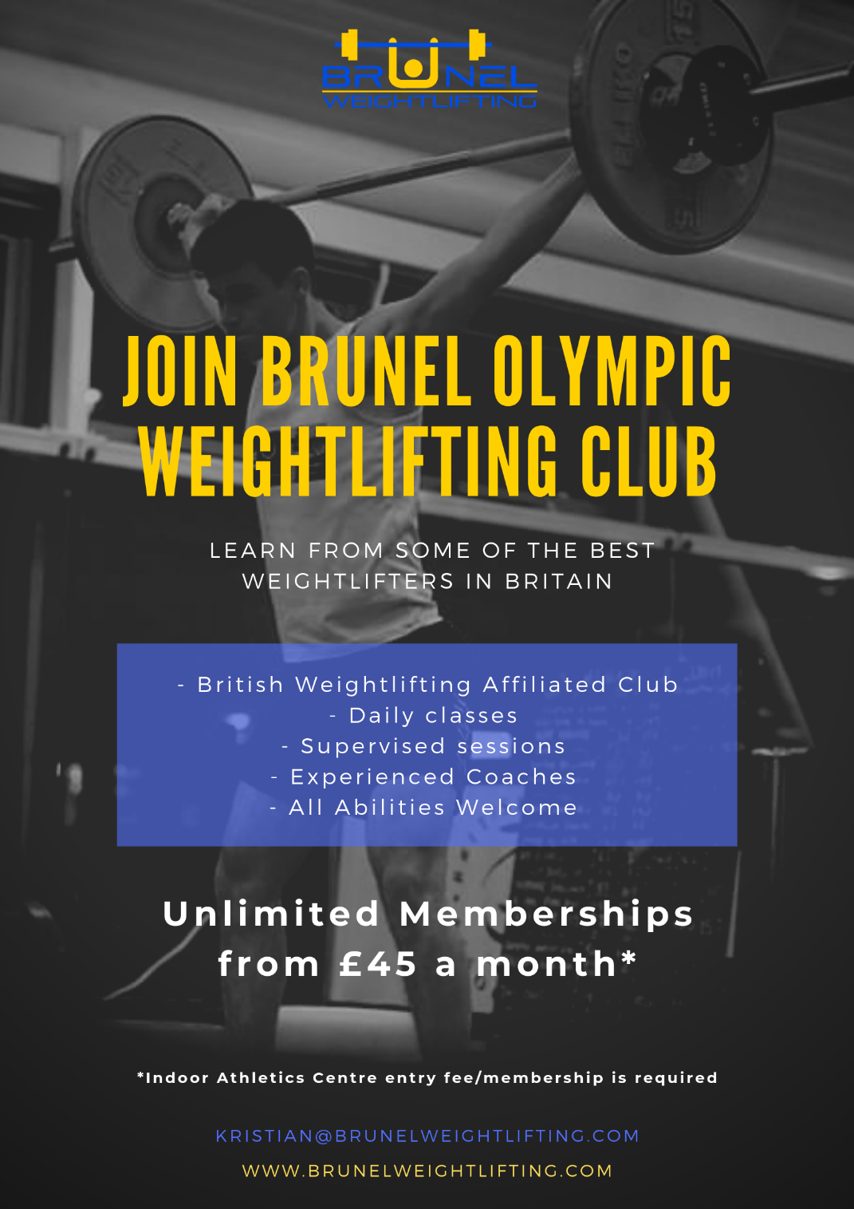
Monday | Tuesday | Wednesday | Thursday | Friday | Saturday | Sunday
5-6.30pm Student Weightlifting Class  (Free for Students with IAC Membership)  Coach: Shafiq Malik & Kristian McPhee | 10-11.30am Weightlifting Club Supervised training (open to all) (must have weightlifting club membership)  Coach: Kristian McPhee | 1.30-3pm Beginner Student Weightlifting Class  (Free for Students) – No IAC membership required  Coach: Kian Panjavi & Kristian McPhee | 10-11.30am Weightlifting Club Supervised training (open to all) (must have weightlifting club membership)  Coach: Kristian McPhee | 12-12:45pm CrossFit  For staff & students  (Must pay IAC entry/membership AND Weightlifting Club Membership)  Coach: Eleonora Calio | 2-3.30pm Weightlifting Class (all abilities)  (Must pay IAC entry/membership AND Weightlifting Club Membership)  Coach: Mike Pearman & Kristian McPhee
6.30-8pm Supervised Training (all abilities)  (Must pay IAC entry/membership AND Weightlifting Club Membership)  Coach: Kristian McPhee | 5-7pm Elite Squad  (Invite only + must have weightlifting club membership)  Coach: Mike Pearman | 3pm-4.30 Student Intermediate Weightlifting Class  (Free for Students with IAC Membership)  Coach: Kian Panjavi & Kristian McPhee | 5-7pm Elite Squad  (Invite only + must have weightlifting club membership)  Coach: Ben Param | 5-6.30 pm Student Weightlifting Class  (Free for Students with IAC Membership)  Coach: Ben Param & Omar Keshta
 | 7-8.30pm Supervised training  (Must pay IAC entry/membership AND Weightlifting Club Membership)  Coach: Shafiq Malik | 7-8pm CrossFit  For staff & students  (Must pay IAC entry/membership AND Weightlifting Club Membership  Coach: Eleonora Calio | 7-8.30pm Beginners Class/Course (Must pay IAC entry/membership AND Weightlifting Club Membership)  Coach: Sophie Bellamy | 7-8.30pm Big Friday Open Training (Unsupervised)
Orange = Student Club| Blue = Weightlifting Public Club | Green = CrossFit
ATTENDEES MUST SIGN UP VIA SCHEDULING APP FOUND VIA brunelweightlifting.com
Training outside of these times only requires IAC membership unless the area is also booked (e.g. externally)

Membership Type | Standard (Open to all) | Student National Level | National Level (Qualified for English/British Seniors or relevant age group (excluding masters and student championships)
Student (this membership not required for the 3 dedicated student sessions) | -Monthly £23.50  - 6 Months £21.50  - 12 Months £18.00 | - Monthly £15  - 6 Months £13.50  - 12 Months £12.50 | - Yearly £90  - Monthly - £10
Public | -Monthly £60  - 6 Months £49  - 12 Months £45
Under 23 | -Monthly £47.50  - 6 Months £40  - 12 Months £37.50
Under 18 | -Monthly £30  - 6 Months £25  - 12 Months £20
All memberships include: Exclusive Trainheroic online program app, unlimited classes (with coaching) and coaching at competitions (where the team go).

